**Installing Zabbix Agent2 on CentOS 7**

● Zabbix is a powerful open-source monitoring software that allows you to monitor the servers, networks, and applications.

● In this documentation I will be installing Zabbix agent on Ubuntu 22.04 .

● The Zabbix Agent is responsible for collecting system data and sending it to the Zabbix server for further analysis and storage.

**How Zabbix agent works:**

Zabbix agent can do both passive **(polling)** and active checks **(trapping)**.

The checks can be performed at an interval or based on specific times schedule. Here is the difference between passive and active checks:

**Passive checks (polling):**

● Zabbix server (or proxy) requests a value from Zabbix agent.

● Agent processes the request and returns the value to Zabbix server (or proxy).

**Active checks (trapping):**

● Zabbix agent requests from Zabbix server (or proxy) a list of active checks.

● The agent sends the results in periodically.

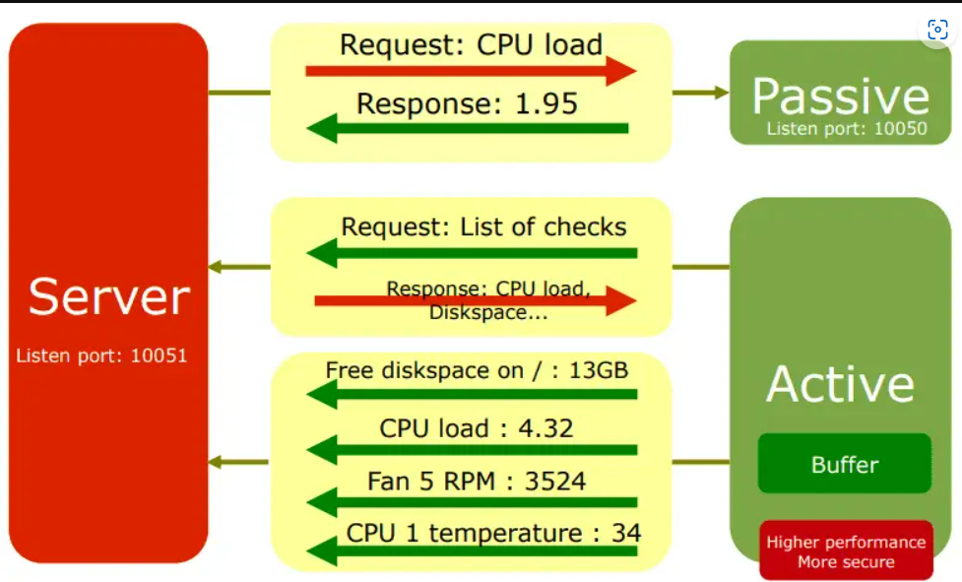

**Prerequisites:**

→ CentOS server 7 or desktop instance.

→ A user account with sudo privileges.

→ Zabbix server up and running.

**Step 1 – Add Required Repository:**

Before installing Zabbix Agent first configure Zabbix yum repository using following commands as per your required version and operating system.



**Step 2: Install Zabbix agent:**

**Note:** Here, when I am using zabbix 6.4 is the latest version.

After installing yum repository packages in our system. Use the following command to install Zabbix agent on your CentOS and Red Hat systems using the yum package manager.

cent ag

**Step 3: Zabbix agent Configuration:**

As Zabbix agent has been successfully installed on our remote system. Now we just need to configure Zabbix agent by adding Zabbix server IP to the configuration file **/etc/zabbix/zabbix_agentd.conf**

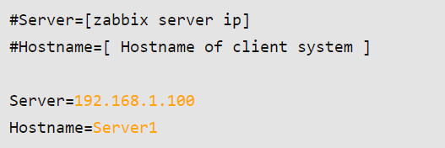

**Step 4: – Open Port**

Zabbix agent uses 10050/tcp port. You are required to open this port to allow the Zabbix server with the agent. Execute command to open port in iptables firewall where 192.168.1.100 is IP of Zabbix server.

**# iptables -A INPUT -p tcp -s 192.168.1.100 --dport 10050 -m state --state NEW,ESTABLISHED -j ACCEPT**

**Step 5: Restarting Zabbix agent:**

After adding Zabbix server IP to the configuration file, now restart agent service to reload the new settings, using the following command.

cent serv res

To start and stop zabbix-agent service anytime use following commands.

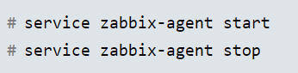

**Step 5: Add the Zabbix Client(Agent) to the Zabbix Server:**

→ Lastly, you need to add the newly installed Zabbix Agent to the Zabbix server.

→ Log in to the Zabbix web interface, navigate to “**Configuration**” > “**Hosts**” > “**Create Host**”, and fill in the necessary details.

→ Select the **group** or **add a new group** for “**Groups**” field.

**IP address**

Zabbix agent service port -default is **10050**

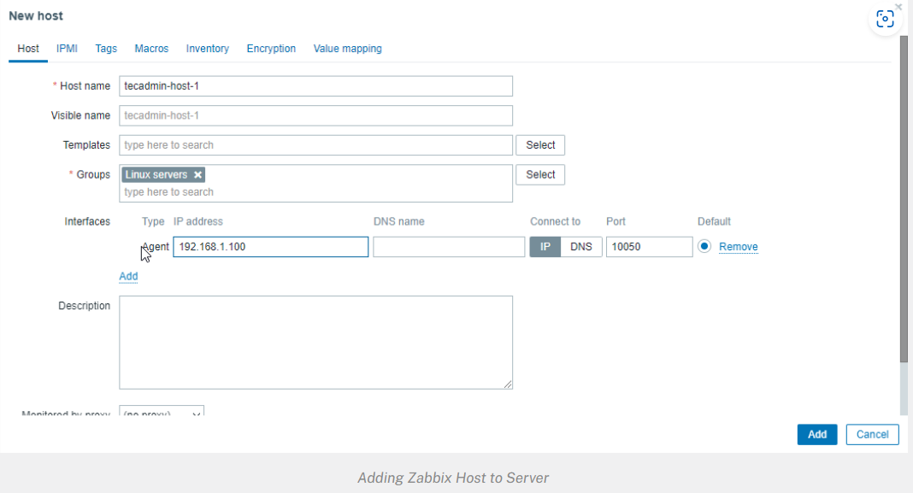

Then go to **Templates** tab.

1. Click the select button and Link new templates section

Select the template you want to use.

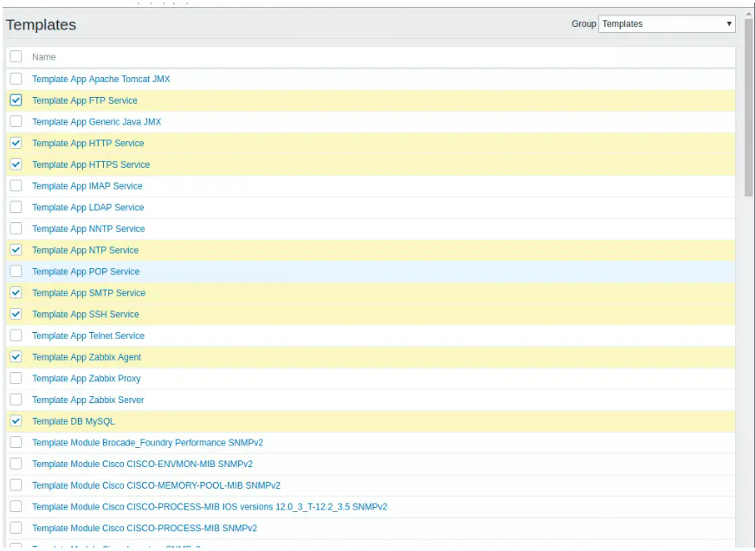

Once you have selected the templates click on the **Add** link to link templates to your target systemAfter the templates are linked, they’ll appear on under **Linked templates** section

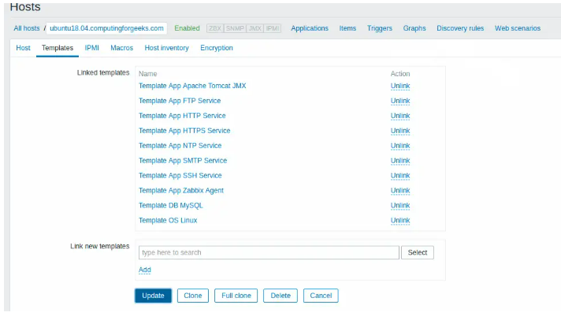

Update the setting using **Update** button. After few minutes, monitoring data will be collected and you can visualize them using Zabbix graphs.

**Monitoring > Graphs > <Host|Graph>**

